2 CFGS Web App Development

Forever Vegan

Web Design Style Guide

What’s Forever Vegan?

Raúl Fernández Arce

INDEX Forever vegan is an association that

tries to help people who is trying

Forever Vegan

To go vegan and don’t know the starting.

Brand name

Color Palette

We are not trying to impose our thoughts,

Typography

we are just trying to make it easy to go vegan

By relating with other people,

Icons

Elements Actions

bringing you some knowledge,

Talking about our testimony…

Navigational Elements

Page Layout

This Brand name describe our website purpose and make people know from start what is this web page aim.

What about Brand name?

The reason why we use this name is to try to make users feel close and, it is a friendly, attractive and informal font, so people’ll feel in a friendlier environment.

Forever Vegan

Our logo has been created by using website name and using “Gluten” Font.

You can download it from [this link](https://fonts.google.com/specimen/Gluten?query=gluten).

Color Palette

Color #1 is going to be used as the main color, color for tittle and footer background.

We are using color #3 for the main background, it’s not a strong color and it brings some color to the website.

We will use color #2 for section buttons or menu separation (in mobile version) to bring it a more colorful and friendly appearance.

Those are the selected colors for Forever Vegan’s website because of their complementary. Both means nature, and as we know, vegan is associated to nature, so I’ve decided to use these colors to decorate the website.

Color #1

Color #2

Color #3

#F2E4DC

#E89464

#009124

This color is full contrast of color #1 we talked about in before’s page.

You should use this color just to attract user’s atention.

This color is used in our website to contrast different elements, for example “read more” buttons, cookies accepting button or things like those.

It’s important to not to abuse of this color because it can make people feel unconfortable by its strength.

#D1000A

Color Palette II

Typography

We are going to use just 2 typographies for this website

‘Alegreya Sans’ is the typography we’ll use for the page content, same as sections description, information, or footer elements, it’s comfortable typeface so people can keep Reading with no problems.

Alegreya Sans

We are using ‘Gluten Font’ because of its friendly appearance and it should be used only for tittles as main page tittle or secitons tittles.

Gluten Font

Elements Actions

The right hover is for the moment the user put the mouse on the “Read More” button we can find in all the sections.

Read More

Read More

This is the animation for the moment we put the mouse on the button, it will shadow for the top right corner in PC layout, we can’t do it in mobile phone, so we are using this hover for PC menu.

Shop

Shop

Icons



We are using icons only in mobile layout, exactly in menu, and in main page of both layout where icons will be matched with his name category.

Icon we have at the left is stronger and it is not black, we don’t need color at icons because our layout has enough of them, overloading the website with colors is not a good idea, so we are doing icons look simple.

We use basic iconography, black to contrast the background, it should be same size as text, so be careful, text has to be important too.

Not to use

Use

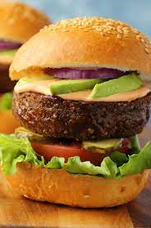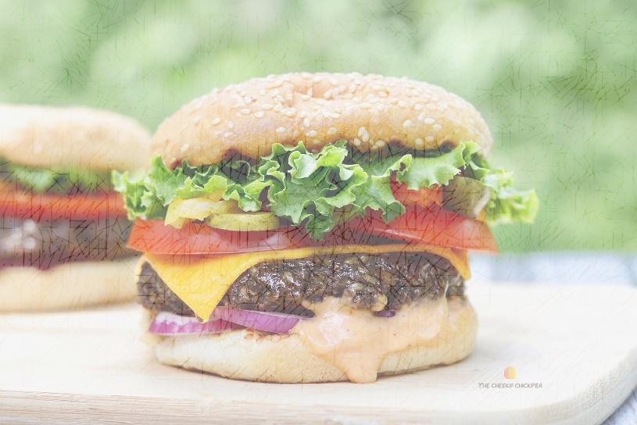

For information content in mobile layout and sections, information content in PC layout we will use images without transparency, and we are putting these images in zigzag to make page dinamic.

For mobile sections layout we will use a background image for the section, but this image should be a little bit transparent because it’s going to have text on it that describes the section content

Icons II

Navigational Elements

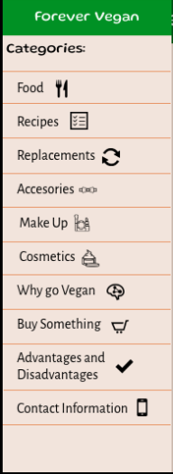

Top menu is the selected one for the PC layout, it interacts with mouse like we talked about in before pages and it change the main layer content using an iframe.

Left element is used for hypertext that allows users to navigate between pages.

www.buyveganingredients.com

Left menu is the one for the mobile layout, it appear once you click on hamburger menu button. When the menu appears, it will translate from left to the middle of the main page, and main one will get darker.

**Font Color**

Font will be black when background color is Color #3 and white when Color #1

**Backgound colours**

The header and footer will have the background main page color, it is Color #1 found in page 4. The background color will be Color #3 at the same page.

**Information Layout**

**Interface Layout**

The website should have a responsive interface to make users from different screen look at the same interface without seeing changes

Information pages will adopt a zigzag layout between elements, in the same way, at the first parafraph text will start from middle to right and at the second one, from left to the middle. Otherwise, images.

Page Layout